

Language: English
Level: Basic
Type: The basics
Duration: 30 min

The basics: Colours and numbers

===============

Colours

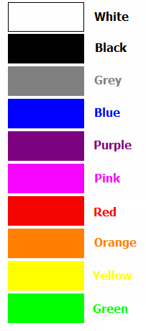

Numbers
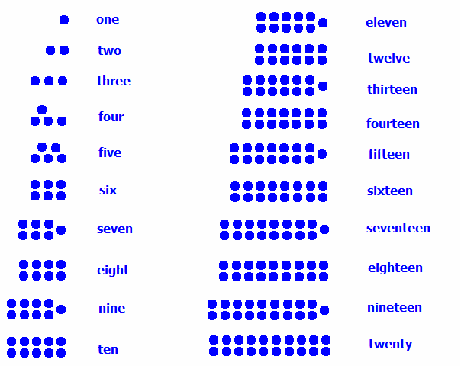

21 - twenty-one  22 - twenty-two  23 - twenty-three  24 - twenty-four  25 - twenty-five  26 - twenty-six  27 - twenty-seven  28 - twenty-eight  29 - twenty-nine  30 - thirty  40 - forty  50 - fifty  60 - sixty  70 - seventy  80 – eighty  90 – ninety | 100- one hundred  200 - two hundred  300 - three hundred  400 - four hundred  500 - five hundred  600 - six hundred  700 - seven hundred  800 - eight hundred  900 - nine hundred  1,000 - one thousand  2,000 - two thousand  3,000 - three thousand  10,000 - ten thousand  100,000 - one hundred thousand  1,000,000 - one million  10,000,000 - ten million

Examples

145 - one hundred and forty-five
2008 - two thousand and eight

Questions

What is your favourite colour?
What colour shoes are you wearing?

What is your age?
What year is it?

===============

If you have written good content for lessons please send them to admin@fluentfuture.com and we will upload it to the learning resources pages.

© Fluent Future Limited.

