

Language: English
Level: Basic
Type: Fruits & Vegetables

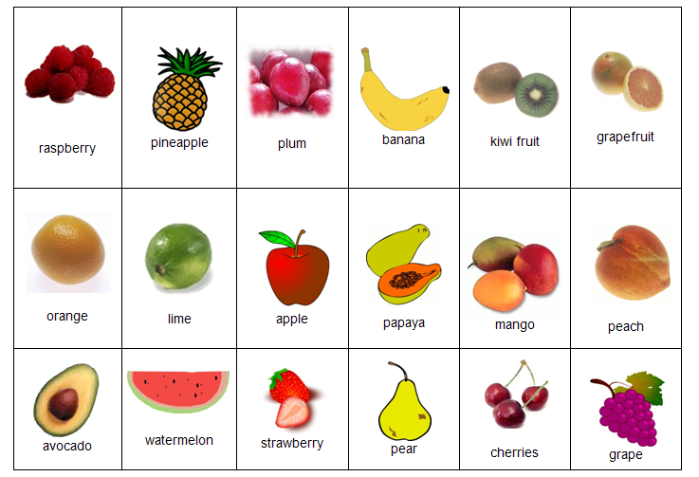
Fruits

What is your favourite fruit?
My favourite fruit is....................

Do you prefer banana or pineapple?
I prefer ...............

Vegetables
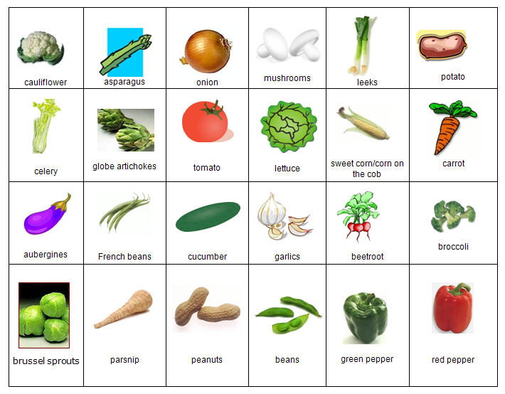

Complete the sentence:

The Top 5 most nutritious vegetables are ........................., ........................., ................................,

.......................... and .......................

If you have written good content for lessons please send them to admin@fluentfuture.com and we will upload it to the learning resources pages.
© Fluent Future Limited.

