

Language: English

Level: Beginner

Type: Time

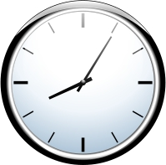
Telling the time

clock

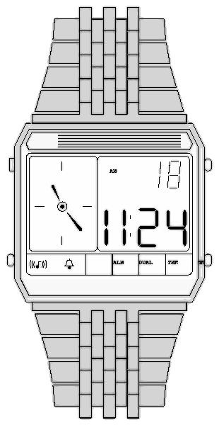
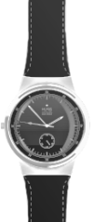

(digital) watch
(analogue) watch

 


 
twelve o´clock (noon/midday)
twelve o´clock (midnight)

6
1
2
3
4
5
7
8
9
10
11
12
6
1
2
3
4
5
7
8
9
10
11
12

eight a.m./eight (o´clock) in the morning

eight p.m. / eight (o´clock) in the evening

12
1
11
6
1
2
3
4
5
7
9
10
11
12

seven a.m. / seven (o´clock)
in the morning

2
10

seven p.m. / seven (o´clock in the evening
3
.
9
4
5
8
8
6
7
12
6
1
2
3
4
5
7
8
9
10
11
12
6
1
2
3
4
5
7
8
9
10
11
12
6
1
2
3
4
5
7
8
11
12
6
1
2
4
5
7
8
9
10
11

seven ten / ten past seven
seven oh five/five past seven

10
nine fifty-five/five to ten
.
seven forty-five/(a) quarter to eight

9
3

What time is it? What time is it?
It´s nine o´clock It´s .....................

Need help? Ask your on-line Fluent Future teacher.

If you have written good content for lessons please send them to admin@fluentfuture.com and we will upload it to the learning resources pages.
© Fluent Future Limited.

